Docker Task -3
Task Description:
Create a custom docker image for nginx and deploy it using docker compose, where the volume bind mount should be at /var/opt/nginx location. Push the created custom docker image to your docker-hub.
Create index.html
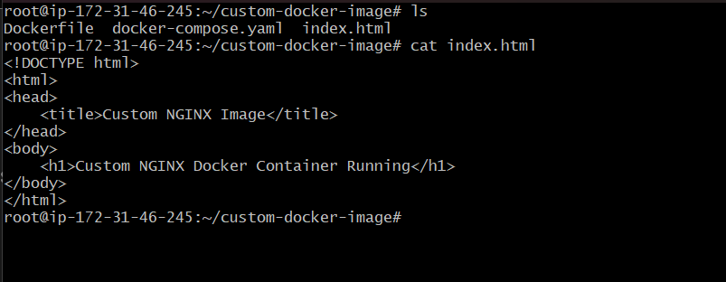
Create Docker file:
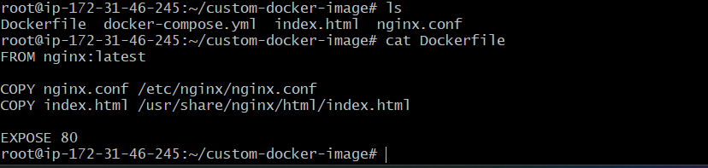
Created docker-compose.yml:
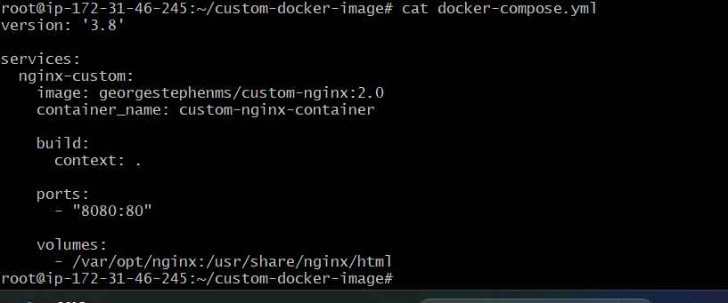

Create nginx.conf
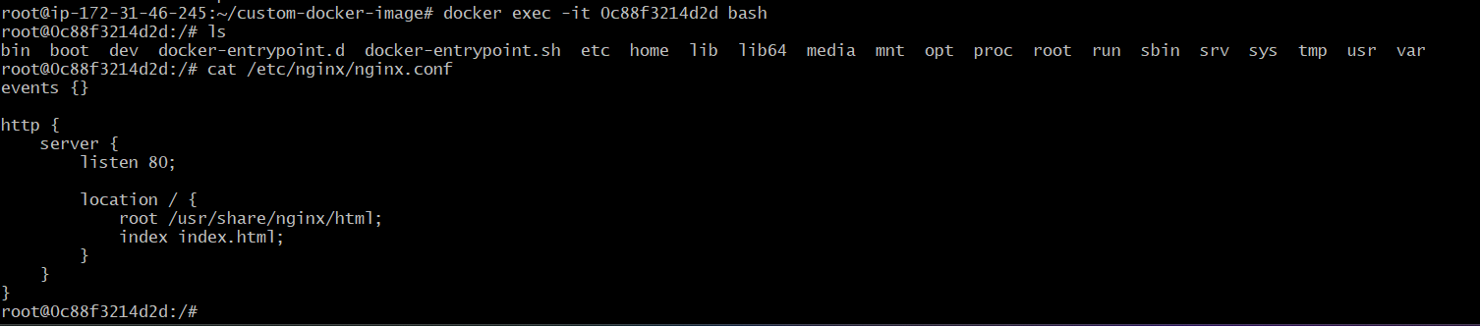

Volume bind mount location created - /var/opt/nginx
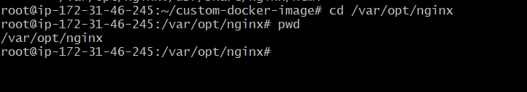
Build Docker Image:
docker build -t georgestephenms/custom-nginx:2.0 .
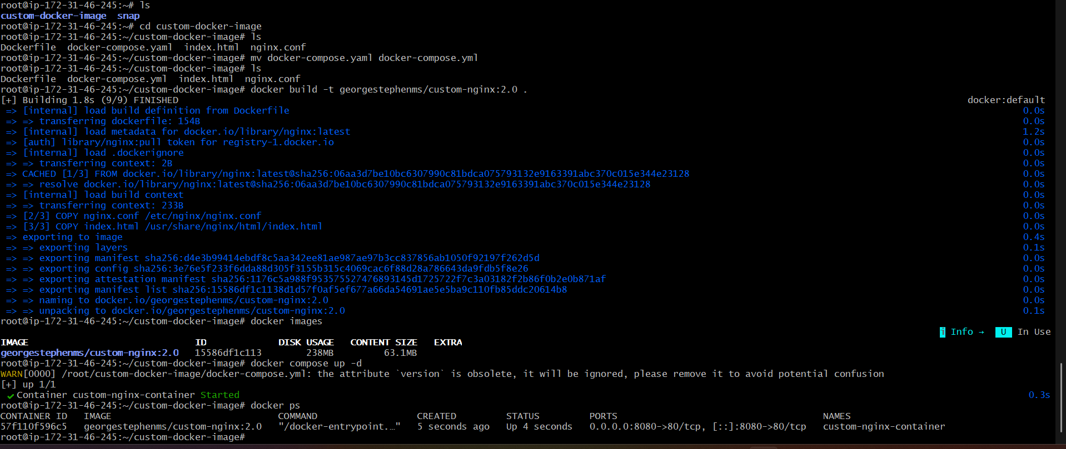
Push the custom Image to Docker Hub:
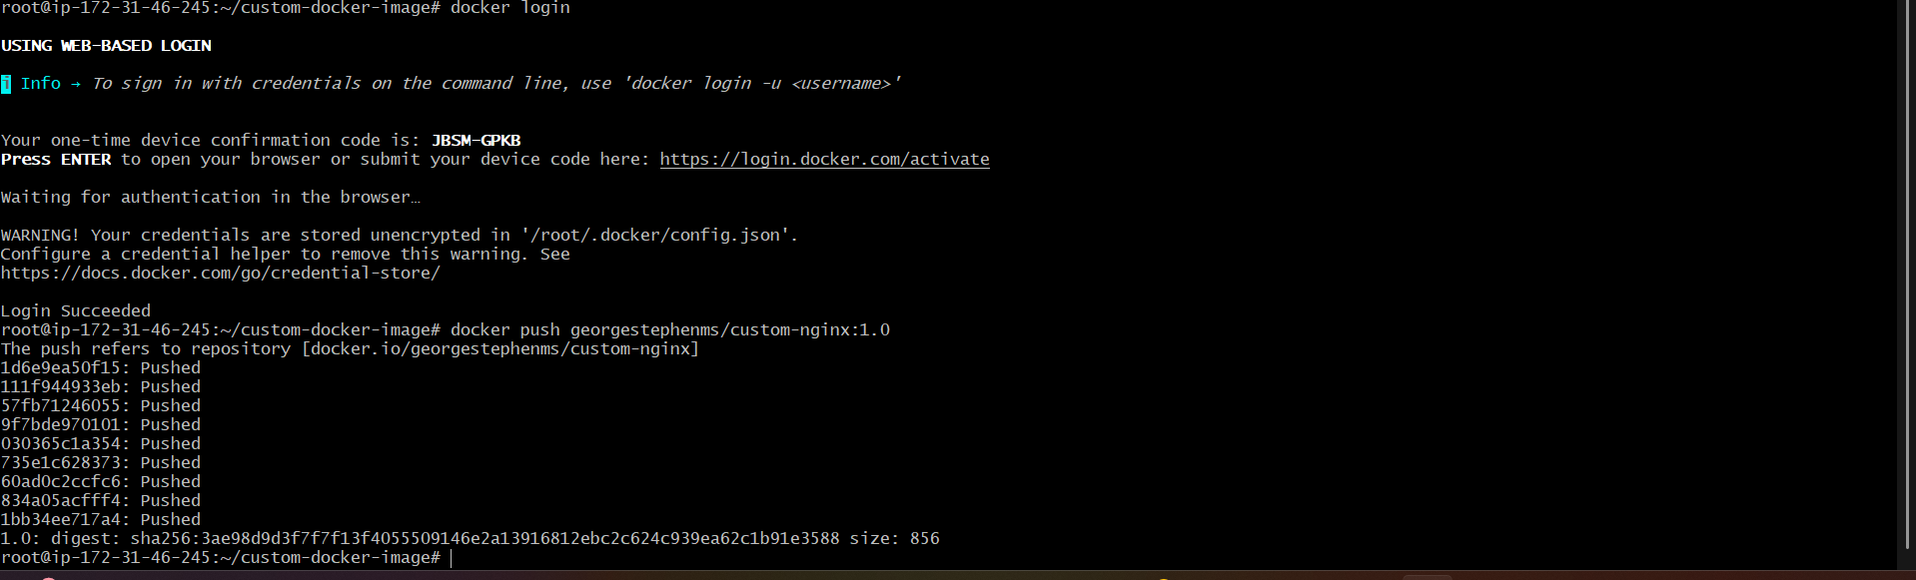
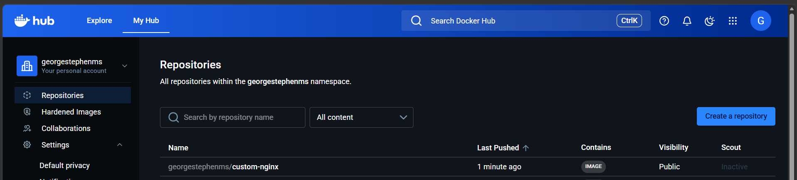
Volume bind mount location updated - /var/opt/nginx
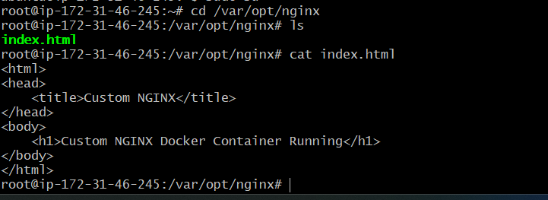
Verify Deployment - http://13.206.98.221:8080/
